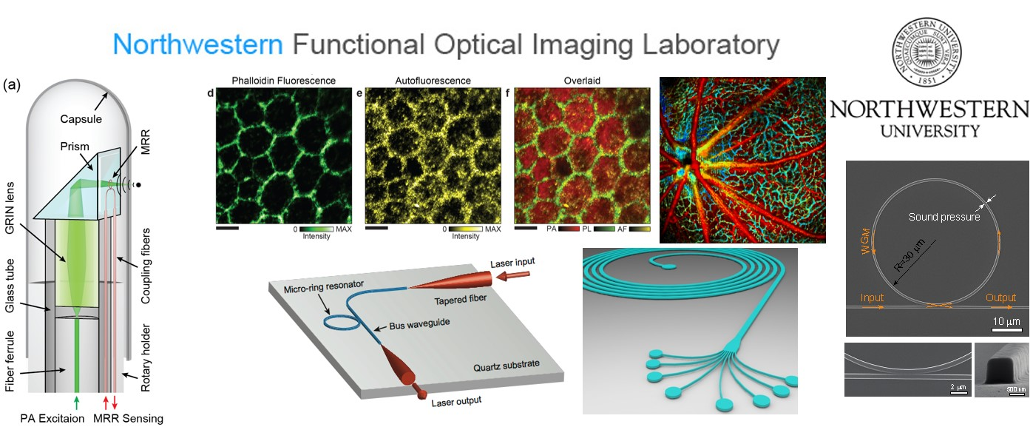

Functional Optical Imaging lab (FOIL) in the Department of Biomedical Engineering at Northwestern University develops optical imaging and sensing technologies for biomedical applications, including ophthalmology, vision science, neuroscience, HIV, and cancers.
We are looking for a computer guru who speaks perfect LabView and C++ to work on a clinical retinal imaging instrumentation project. The successful candidate is expected to work on both Evanston and Chicago campuses. For more information, please visit the FOIL website http://foil.northwestern.edu or contact Prof. Hao F. Zhang (hfzhang @ northwestern.edu).

