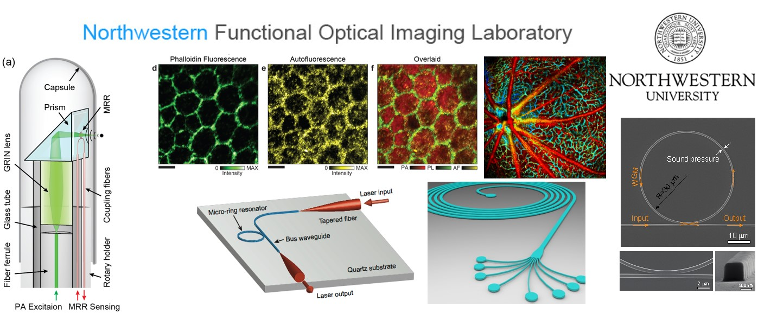

Functional Optical Imaging lab (FOIL) in the Department of Biomedical Engineering at Northwestern University develops optical imaging and sensing technologies for biomedical applications, including ophthalmology, vision science, neuroscience, HIV, and cancers.
We are looking for two new Ph.D. students to join our extremely friendly, vibrant, productive, and collaborative group. Students with interests and research experiences in optics are strongly encouraged to apply. For more information, please visit the FOIL website http://foil.northwestern.eduor contact Prof. Hao F. Zhang (hfzhang @ northwestern.edu).
For more information regarding Northwestern University, the City of Evanston, and the greater Chicago metropolitan area, please visit http://www.tgs.northwestern.edu/

